**Ohmic resistance and Ohm’s law**

In this experiment, you will be using a resistor, with characteristics similar to the metals that make up wires and the heating elements in electrical appliances. You will discover the relationship known as ‘Ohms Law’

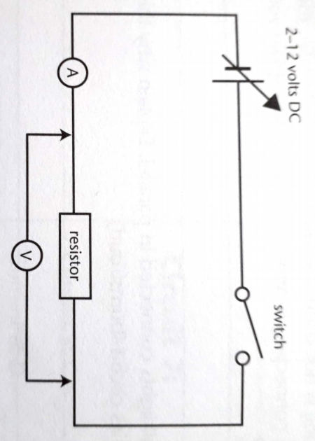**Diagram of the experiment**

**Results**

* Record the current for voltages from 0 volts to the 12 volt setting of the power supply in a suitable results table.
* Plot the voltage (y-axis) against the current (x-axis).
* The gradient of the graph is called the ‘resistance’. From the graph calculate the resistance of your resistor.
* On your graph, draw a line you predict you could get a higher value resistance and one you could get for a line of lower value of resistance.

**Safety**

* Safety glasses are essential during the experiment.
* Ensure power is off when constructing circuits.
* Ensure all circuits are properly connected.

**Ohmic resistance and Ohm’s Law**

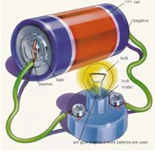

I In groups of 2-4, plan and conduct the Investigation.

Complete your write-up individually.

|  |  |  |  |
| --- | --- | --- | --- |
|  |  | Mark Allocation | Mark |
| Title | * Title relevant and concise | 1 |  |
| Aim and Hypothesis | * Aim is clear and concise * Hypothesis relates independent and dependent variables | 2 |  |
| Variables | * Independent variable is identified * Dependant variable is identified * 3-5 controlled variables identified | 3 |  |
| Results | * Table includes title which relates variables * Columns relate to independent and dependent variables and include headings with units * Calculation of Gradient (resistance) | 3 |  |
| Graph | * Graph title relates variables * Graph type appropriate for data * Axis correct orientation and labelled, including units * Appropriate size and scale * Predicted lines of lower and higher resistance values. | 5 |  |
| Discussion | * Results summarised and patterns identified * Explanation of results using scientific knowledge * Difficulties or sources of error identified * Specific suggestions for improvement or further experimentation | 4 |  |
| Conclusion | * Summary of findings * Hypothesis supported or not. | 2 |  |
|  |  | Total  /20 |  |